**MYSQL ASSIGNMENT 3**

create table ASSIGNMENT(

emp_id int primary key,

first_name varchar(50),

last_name Varchar(50),

department varchar(50),

salary int,

hire_date int);

insert into ASSIGNMENT (emp_id, first_name, last_name, department, salary, hire_date)

values

(1,"John","Doe","IT",60000,2019-01-10),

(2,"Jane","Smith","HR",55000,2018-03-05),

(3,"Emily","Jones","IT",62000,2020-07-23),

(4,"Michael","Browm","Finance",70000,2016-05-14),

(5,"Sarah","Davis","Finance",69000,2017-11-18),

(6,"David","Johnson","HR",48000,2021-09-10);

**select * from ASSIGNMENT;**

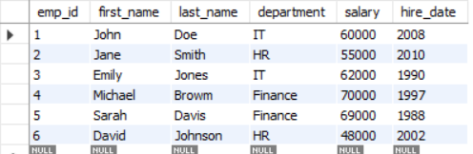

1. Find the average salary of employees in each department.

**#SELECT department, avg(salary) from ASSIGNMENT group by department;**

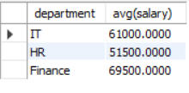

1. **Find the total number of employees hired after 2019.**

**#select count(hire_date)as "employees hired after 2019" from ASSIGNMENT where hire_date >"2019-01-10";**



1. List the departments and the total salary of all employees in each department, ordered by the total salary.

**#SELECT department, SUM(salary) AS total_salary from ASSIGNMENT GROUP BY department ORDER BY total_salary DESC;**

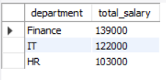

1. Find the highest salary in the Finance department.

**#select department, sum(salary)as " the total salary of all employees in each department" from ASSIGNMENT group by department order by sum(salary);**

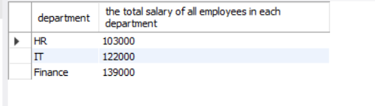

1. Get the top 3 highest-paid employees.

**select first_name, last_name, salary from ASSIGNMENT order by salary DESC limit 3;**

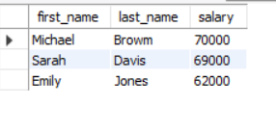

1. Find the department with the minimum average salary.

**SELECT Department, AVG(Salary) AS Avg_Salary from ASSIGNMENT GROUP BY Department ORDER BY Avg_Salary ASC LIMIT 1;**

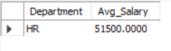

1. Display the total number of employees in each department, ordered by the number of employees.

**select emp_id,concat(first_name, " ", last_name)as employee_name, salary from ASSIGNMENT order by "salary" DESC limit 3;**

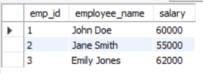

1. Find the average salary of employees who were hired before 2020.

**select department from ASSIGNMENT group by department order by avg(salary) ASC limit 3;**

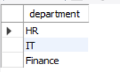

1. List the names of employees in the IT department ordered by hire date, with the most recently hired employees first.

**select department, count(*) as employee_count from ASSIGNMENT group by department order by employee_count ASC;**

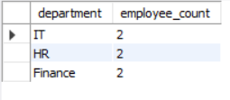

1. Find the sum of salaries for all employees hired after January 1, 2019, ordered by salary.

**select avg(salary) as "average salary" from ASSIGNMENT where hire_date < '2020-01-01';**

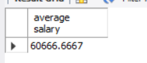

1. Get the employee with the lowest salary in the HR department.

**select concat(first_name,"",last_name)as employee_name from ASSIGNMENT where department = 'HR' order by hire_date;**

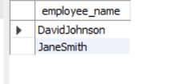

1. Find the total salary paid to employees in each department, but limit the result to the top 2 highest-paying departments.

**SELECT Department, SUM(Salary) AS Total_Salary from ASSIGNMENT GROUP BY Department ORDER BY Total_Salary DESC LIMIT 2;**

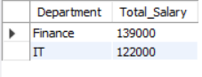

1. List all employees hired after 2018, ordered by salary, and show only the first 4 employees.

**SELECT first_name, hire_date, Salary from ASSIGNMENT WHERE hire_date > '2018-12-31' ORDER BY salary DESC LIMIT 4;**



1. Find the highest salary in the IT department, but limit the results to the top 1 result.

**select first_name, salary from ASSIGNMENT where department = "IT" order by salary ASC limit 1;**

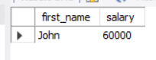

1. Get the average salary of employees in each department and list only departments with an average salary greater than $60,000.

**SELECT Department, AVG(Salary) AS AverageSalary from ASSIGNMENT GROUP BY Department HAVING AVG(Salary) > 60000;**

